**SL Unit 4** **– Problem Solving**  
Quiz 3

|  |  |  |  |
| --- | --- | --- | --- |
| **Question 1** | | | |
| Objectives: | 4.2.5 | Exam Reference: | May-16 10 |

Trace the following fragment, for N=139 and L=3, by copying and completing the trace table given  
below.

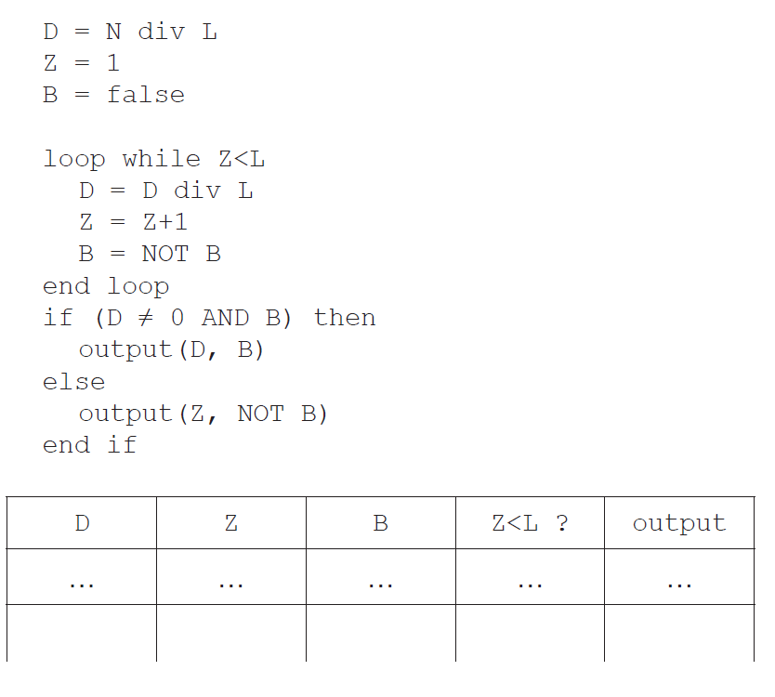

[4]

|  |  |  |  |
| --- | --- | --- | --- |
| **Question 2** | | | |
| Objectives: | 4.2.5, 4.2.6, 4.2.7, 4.3.13 | Exam Reference: | May-17 12 |

1. 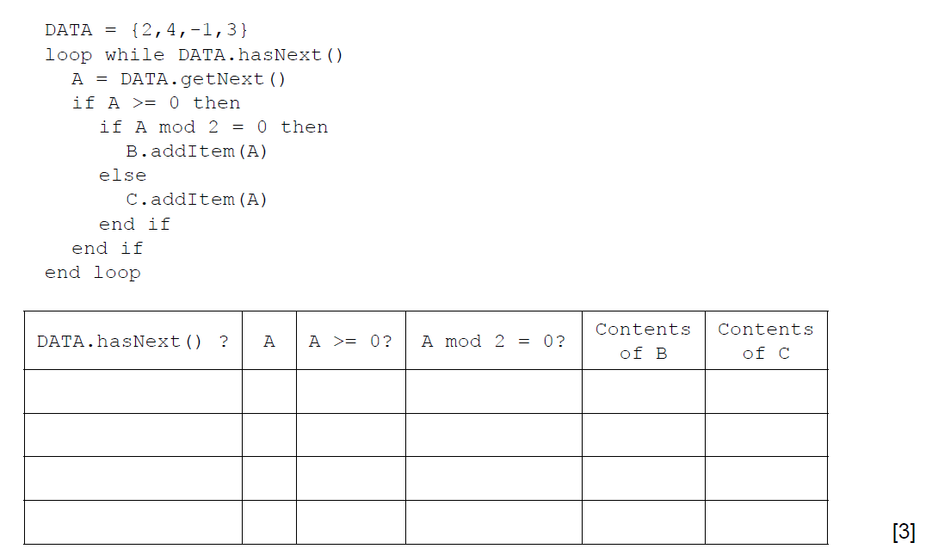 (a) By copying the table below, trace the following algorithm using the data in   
    the collection DATA. Note: B and C are also collections and are initially empty.

1. Outline the steps involved in performing a binary search on an array of ascending numbers.   
   **Note**: you can assume that the search value is present in the array and that initially LOW is the index of the first value in the array and HI is the index of   
   the last value. [4]

1. A collection called NUMBERS is to be searched to see if it contains a specified value.   
   Construct an algorithm in pseudocode to perform the following:

* input the number, S, to be searched for
* read in the values from the NUMBERS collection into the array D.   
  **Note**: you can assume that the array is large enough and that the collection is **not** empty
* perform a linear search for S on the array D
* output the message “found” or “not found” as appropriate. [5]

A binary search can be performed on the array D, if the values in D are in ascending order.  
 As the values are being read from NUMBERS into D they are checked to see if they are in order.

1. Without writing pseudocode, suggest how this check could be performed. [3]

|  |  |  |  |
| --- | --- | --- | --- |
| **Question 3** | | | |
| Objectives: | 4.3.4 | Exam Reference: | Nov-14 4 |

Outline the need for higher level languages. [2]

|  |  |  |  |
| --- | --- | --- | --- |
| **Question 4** | | | |
| Objectives: | 4.1.3 | Exam Reference: | May-15 3 |

Outline how a sub-procedure can be considered an example of abstraction. [2]

|  |  |  |  |
| --- | --- | --- | --- |
| **Question 5** | | | |
| Objectives: | 4.3.3 | Exam Reference: | Nov-17 1 |

Identify **two** essential features of a computer language. [2]